Regression vs. Classification in Machine Learning
Regression and Classification algorithms are Supervised Learning algorithms. Both the algorithms are used for prediction in Machine learning and work with the labeled datasets. But the difference between both is how they are used for different machine learning problems.
The main difference between Regression and Classification algorithms that Regression algorithms are used to predict the continuous values such as price, salary, age, etc. and Classification algorithms are used to predict/Classify the discrete values such as Male or Female, True or False, Spam or Not Spam, etc.
Consider the below diagram:
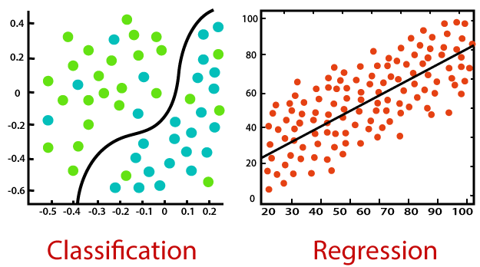

Classification:
Classification is a process of finding a function which helps in dividing the dataset into classes based on different parameters. In Classification, a computer program is trained on the training dataset and based on that training, it categorizes the data into different classes.
The task of the classification algorithm is to find the mapping function to map the input(x) to the discrete output(y).
Example: The best example to understand the Classification problem is Email Spam Detection. The model is trained on the basis of millions of emails on different parameters, and whenever it receives a new email, it identifies whether the email is spam or not. If the email is spam, then it is moved to the Spam folder.
Types of ML Classification Algorithms:
Classification Algorithms can be further divided into the following types:
- Logistic Regression
- K-Nearest Neighbours
- Support Vector Machines
- Kernel SVM
- Naïve Bayes
- Decision Tree Classification
- Random Forest Classification

Regression:
Regression is a process of finding the correlations between dependent and independent variables. It helps in predicting the continuous variables such as prediction of Market Trends, prediction of House prices, etc.
The task of the Regression algorithm is to find the mapping function to map the input variable(x) to the continuous output variable(y).
Example: Suppose we want to do weather forecasting, so for this, we will use the Regression algorithm. In weather prediction, the model is trained on the past data, and once the training is completed, it can easily predict the weather for future days.
Types of Regression Algorithm:
- Simple Linear Regression
- Multiple Linear Regression
- Polynomial Regression
- Support Vector Regression
- Decision Tree Regression
- Random Forest Regression

Difference between Regression and Classification
Regression Algorithm | Classification Algorithm
In Regression, the output variable must be of continuous nature or real value. | In Classification, the output variable must be a discrete value.
The task of the regression algorithm is to map the input value (x) with the continuous output variable(y). | The task of the classification algorithm is to map the input value(x) with the discrete output variable(y).
Regression Algorithms are used with continuous data. | Classification Algorithms are used with discrete data.
In Regression, we try to find the best fit line, which can predict the output more accurately. | In Classification, we try to find the decision boundary, which can divide the dataset into different classes.
Regression algorithms can be used to solve the regression problems such as Weather Prediction, House price prediction, etc. | Classification Algorithms can be used to solve classification problems such as Identification of spam emails, Speech Recognition, Identification of cancer cells, etc.
The regression Algorithm can be further divided into Linear and Non-linear Regression. | The Classification algorithms can be divided into Binary Classifier and Multi-class Classifier.

